**Walk 12 Stoke Prior and the Lugg**

Last walked in May 2017

**Description.**  A 5 km (3.1 miles) edited version of Hereford Times walk by Garth Lawson. A walk along country lanes and the river Lugg, with easily attained views and wildlife.

**Start.** Explorer Map 202. Grid. 523565.

**Direction from Whitecross roundabout** (Turn milometer to zero). Take the A4110 Canon Pyon (Three Elms road) for 1 mile and TR at the traffic lights onto the A4103 to Worcester (Roman road). Turn L at the first roundabout (2 mile), onto the A49 to Leominster. At 9.5 miles you go straight across the 2nd roundabout towards Shrewbury on the A49. At 10.5 miles TR on a minor road to Stoke Prior/Golf Course. At 11.8 miles, near to Stoke Prior church, park on the side of the road. Or a bit further on at the road junction.

**1. Stoke Prior.** Taking the start point to be the road junction island in the centre of the village, head up the road as if for Leominster. You go past an old Post Office on the R that has a number of old signs for food: Lloyds Tea, Colman’s Mustard etc., and further on you go past the Lamb Inn (closed) on your L, with its large car park. After about ½ km, on your R you go past a gated drive going up to a white house called ‘The Slough, and 80m further on, by a hidden sign post and what’s L of a barn, you TR to go thru a gate and along an enclosed track. After 75m you go thru a stile/gate and along the L edge of an orchard, to cross a stile into a field **F1**. Go along the L edge which bends L after about 20m.

**2. Copse.** A little further on the field edge bends R but you go straight on along a narrow path and into the copse. Keep ahead at the path junction, going under telegraph lines and on thru a gate into **F2**. Keep ahead and go thru a small field that has ant-hills. Go thru waymarked gap in a line of trees ahead (with great views of the Black Mountains and Radnor Forest). Keep ahead to cross a stile into **F3**, then you pass a way marker post on your L and veer L, to join a hedge on your L hand side. Continue down the path to the bottom of the field, cross over a farm track and go down the bank into a ditch called Hollow Way. TL to go over a stile and walk down an enclosed gully to pass to the L of Eaton House, over a stile and on to a country lane.

**3. Eaton.** TR, walk along the country lane for 195m to TL at a tarmac drive. Continue along the drive and thru the gates to reach the end of the farmyard, where you continue in the same direction, going in-between buildings (Stables are on the L), to reach the river Lugg beneath the Scots Pines. Going a little to your L you cross the River Lugg and weir via Eaton Hall Bridge and the Millennium Gate.

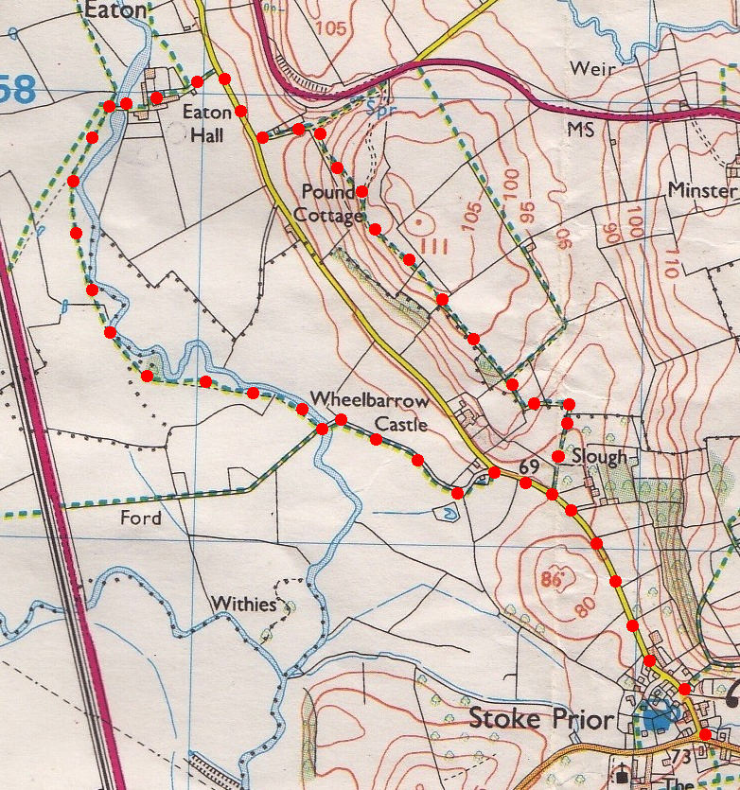4. **Eaton Hall’s 17th Century Stone Bridge.** ***The next ¾ mile (1.2km) along the Lugg are a favoured place to spot a kingfisher***. TL along the river bank, soon using two stiles to keep to the edge. Skirt past an extravagant loop in the Lugg, cross a stile that by the water’s edge and cross a stile in L corner next to the bridge. ***Favoured area for otters and hares.***

**4**

**3**

**5. Volca Bridge.** TL thru the gate and across Volca Bridge to then TR and cross over a three-plank foot bridge into a field. TL and follow the L edge. Go thru a gate in the L corner and across a loose stone driveway that goes to horse stables on the R, go thru another gate and into a field. Continue along the L field edge to cross over a stile in the corner to go down three steps onto the road. TR and return along road to Stoke Prior village.

**5**

2

**1**